Simple Windmill
Description:
A basic windmill project using a DC motor and fan blades to demonstrate energy conversion from wind to electrical energy.
Block Diagram:
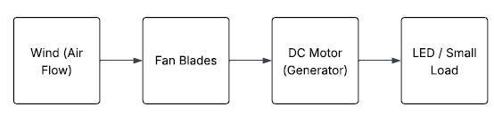
Pinout / Circuit Connection:
- DC Motor → connected to fan blade
- Motor terminals → LED with resistor or small load
Components Required:
- DC Motor
- Fan Blade
- LED
- Resistor
- Wooden/Plastic base
Working Principle:
The fan blades rotate when wind is applied, spinning the DC motor, which generates electricity to power an LED.
Operation (Step-by-Step):
- Fix DC motor to a base.
- Attach fan blade to motor shaft.
- Connect motor terminals to LED with resistor.
- Blow air or use fan to rotate blade.
- Observe LED glow.
Arduino Code:
// No Arduino code required (pure hardware project).
Conclusion: (Predefined/self-written)
The windmill demonstrates renewable energy by converting wind into electricity.
For Your References:
[1] Electronics Tutorials, 'DC Motor Basics,' https://www.electronics-tutorials.ws/dcmotor

